Sullivan Ballou Letter

July 14, 1861 Camp Clark, Washington

My very dear Sarah:
The indications are very strong that we shall move in a few days—perhaps tomorrow. Lest I should not be able to write again, I feel impelled to write a few lines that may fall under your eye when I shall be no more . . .

I have no misgivings about, or lack of confidence in the cause in which I am engaged, and my courage does not halt or falter. I know how strongly American Civilization now leans on the triumph of the Government and how great a debt we owe to those who went before us through the blood and sufferings of the Revolution. And I am willing—perfectly willing—to lay down all my joys in this life, to help maintain this Government, and to pay that debt . . .

Sarah my love for you is deathless, it seems to bind me with mighty cables that nothing but Omnipotence could break; and yet my love of Country comes over me like a strong wind and bears me unresistibly on with all these chains to the battle field.

The memories of the blissful moments I have spent with you come creeping over me, and I feel most gratified to God and to you that I have enjoyed them for so long. And hard it is for me to give them up and burn to ashes the hopes of future years, when, God willing, we might still have lived and loved together, and seen our sons grown up to honorable manhood, around us. I have, I know, but few and small claims upon Divine Providence, but something whispers to me—perhaps it is the wafted prayer of my little Edgar, that I shall return to my loved ones unharmed. If I do not my dear Sarah, never forget how much I love you, and when my last breath escapes me on the battle field, it will whisper your name. Forgive my many faults and the many pains I have caused you. How thoughtless and foolish I have often times been! How gladly would I wash out with my tears every little spot upon your happiness . . .

But, O Sarah! If the dead can come back to this earth and flit unseen around those they loved, I shall always be near you; in the gladdest days and in the darkest nights . . . always, always, and if there be a soft breeze upon your cheek, it shall be my breath, as the cool air fans your throbbing temple, it shall be my spirit passing by. Sarah do not mourn me dead; think I am gone and wait for thee, for we shall meet again . . .
Sullivan Ballou
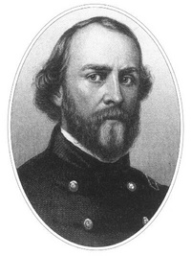
Omnipotence - the state of being omnipotent; having unlimited power.
Blissful - Extremely happy; full of joy
Misgivings - A feeling of doubt about the outcome or consequences of something.

Sullivan Ballou Biography
Sullivan Ballou was killed a week later at the first Battle of Bull Run, July 21, 1861.
Born March 28, 1829 in Smithfield, R.I., Ballou was educated at Phillips Academy in Andover, Mass.; Brown University in Providence, R.I. and the National Law School in Ballston, N.Y. He was admitted to the Rhode Island Bar in 1853.

Ballou devoted his brief life to public service. He was elected in 1854 as clerk of the Rhode Island House of Representatives, later serving as its speaker.
He married Sarah Hart Shumway on October 15, 1855, and the following year saw the birth of their first child, Edgar. A second son, William, was born in 1859.
Ballou immediately entered the military in 1861 after the war broke out. He became judge advocate of the Rhode Island militia and was 32 at the time of his death at the first Battle of Bull Run on July 21, 1861.

When he died, his wife was 24. She later moved to New Jersey to live out her life with her son, William, and never re-married. She died at age 80 in 1917.
Sullivan and Sarah Ballou are buried next to each other at Swan Point Cemetery in Providence, RI. There are no known living descendants.

Ironically, Sullivan Ballou’s letter was never mailed. Although Sarah would receive other, decidedly more upbeat letters, dated after the now-famous letter from the battlefield, the letter in question would be found among Sullivan Ballou’s effects when Gov. William Sprague of Rhode Island traveled to Virginia to retrieve the remains of his state’s sons who had fallen in battle.

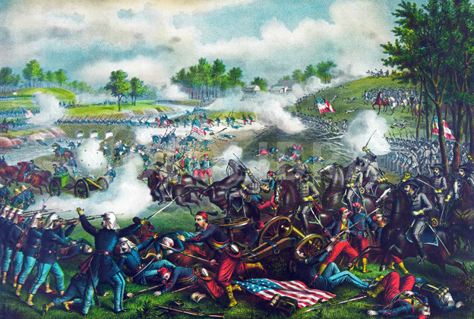
The First Battle of Bull Run
Name: _____________________________________ Period: ____ /12
Sullivan Ballou’s Letter Questions
Directions: After reading the Sullivan Ballou Letter and Biography answer the questions below in a complete sentence. Be sure to explain each of your answers

- Is this document a primary or secondary resource? How do you know?

- When and where was this letter written?

- Did Sullivan Ballou believe in the cause he was fighting for? How do you know?

- What does Sullivan say about the men who fought in the American Revolution?

- What is the main thing Sullivan was trying to convey or tell his wife?

- What happened to Sullivan only a week later and where did this happen?

- How old was Sullivan when he died? Who did he leave behind?

- Where is Sullivan buried? Who is he buried next to?

- How did you feel after reading the letter and then finding out what happened to Sullivan?

- Do you think the sacrifice Sullivan Ballou and an estimated 625,000 other Americans made during the Civil War was worth it? Explain your answer in 3 complete sentences.

